**DAILY ONLINE ACTIVITIES SUMMARY**

|  |  |  |  |  |  |  |  |  |
| --- | --- | --- | --- | --- | --- | --- | --- | --- |
| **Date:** | **22-05-2020** | | | | | **Name:** | **Sinchana** | |
| **Sem & Sec** | **6 B** | | | | | **USN:** | **4AL17CS117** | |
| **Online Test Summary** | | | | | | | | |
| **Subject** | | **OR** | | | | | | |
| **Max. Marks** | | **30** | | **Score** | | | **30** | |
| **Certification Course Summary** | | | | | | | | |
| **Course** | **Python for Machine Learning** | | | | | | | |
| **Certificate Provider** | | | **Greatlearning academy** | | **Duration** | | | **5.0 hours** |
| **Coding Challenges** | | | | | | | | |
| **Problem Statement: 1. Separate character. 2.Operation of SLL 3.Largest and smallest string** | | | | | | | | |
| **Status: Success** | | | | | | | | |
| **Uploaded the report in Github** | | | | | **Yes** | | | |
| **If yes Repository name** | | | | | **coding** | | | |
| **Uploaded the report in slack** | | | | | **Yes** | | | |

Online Test Details: (Attach the snapshot and briefly write the report for the same)

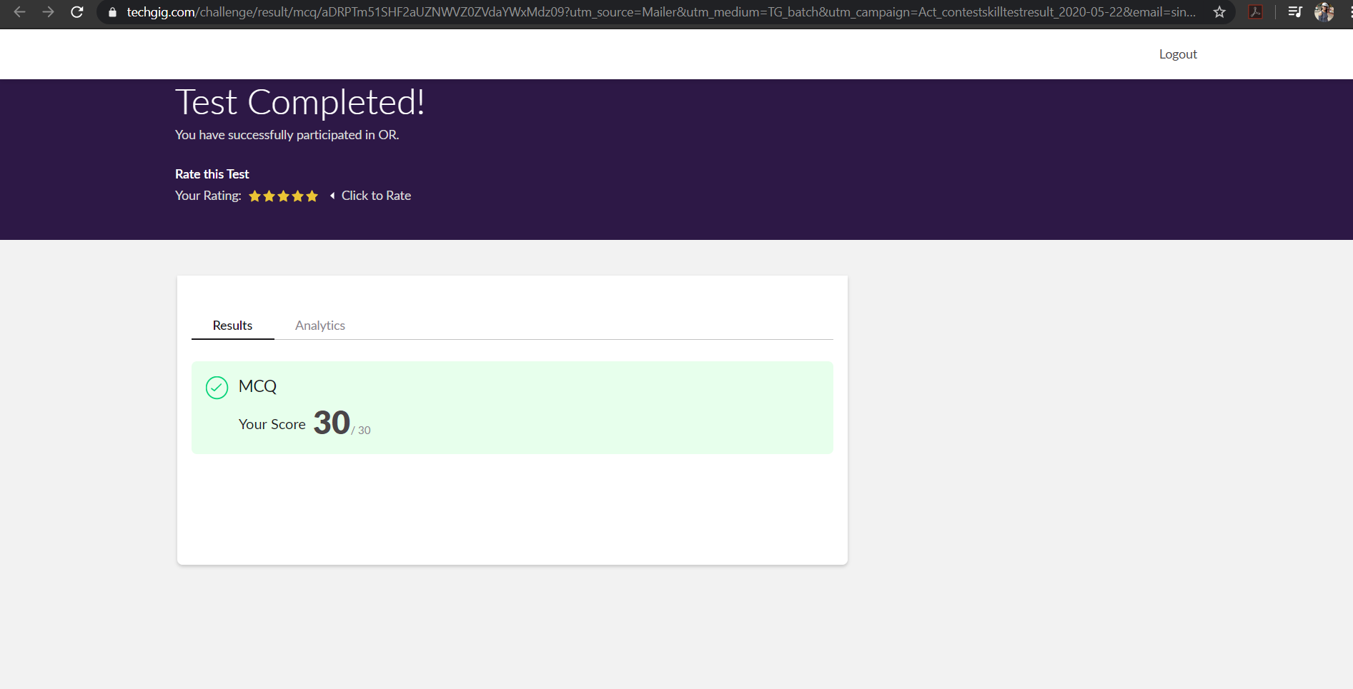

The test was held between 9:30 am to 10:00 am. It consisted of only 1 round and the total marks assigned was 30.The above snapshot is the output of my 1st IA test.

Certification Course Details: (Attach the snapshot and briefly write the report for the same)

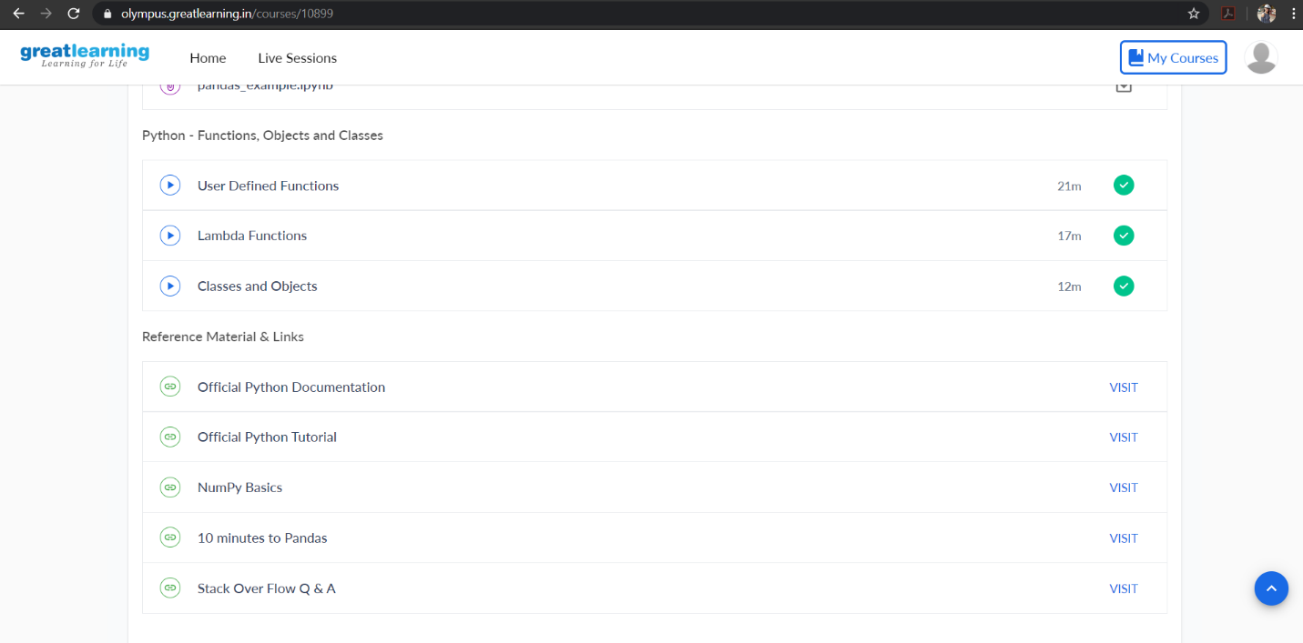

Online Certification Course Summary: Today I have continued with the course and learnt about user-defined function's declaration which begins with the keyword def and followed by the function name. The function may take arguments(s) as input within the opening and closing parentheses, just after the function name followed by a colon. After defining the function name and arguments(s) a block of program statement(s) start at the next line and these statement(s) must be indented.

Coding Challenges Details: (Attach the snapshot and briefly write the report for the same)

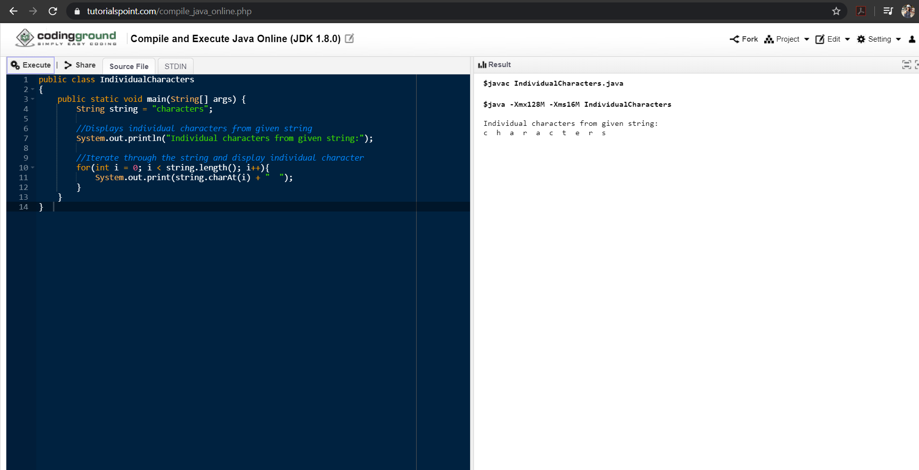

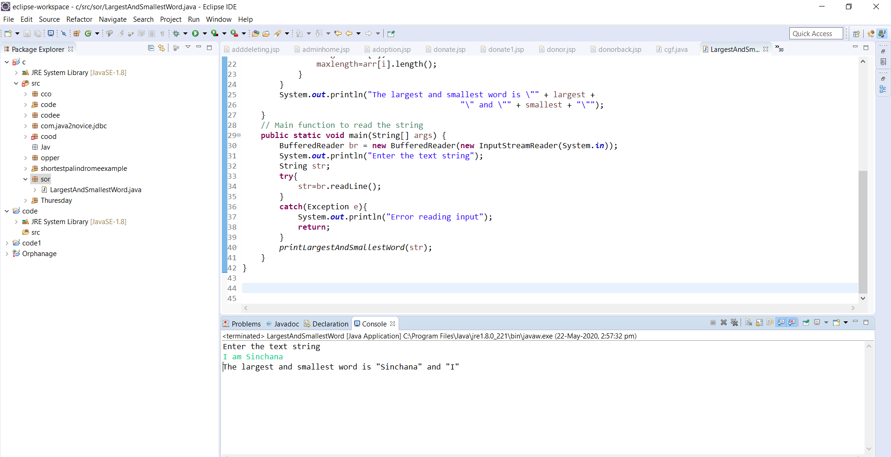

Link in GitHub : <https://github.com/sinchana514/coding>

<https://github.com/sinchana514/coding/tree/master/22%20nd%20may>